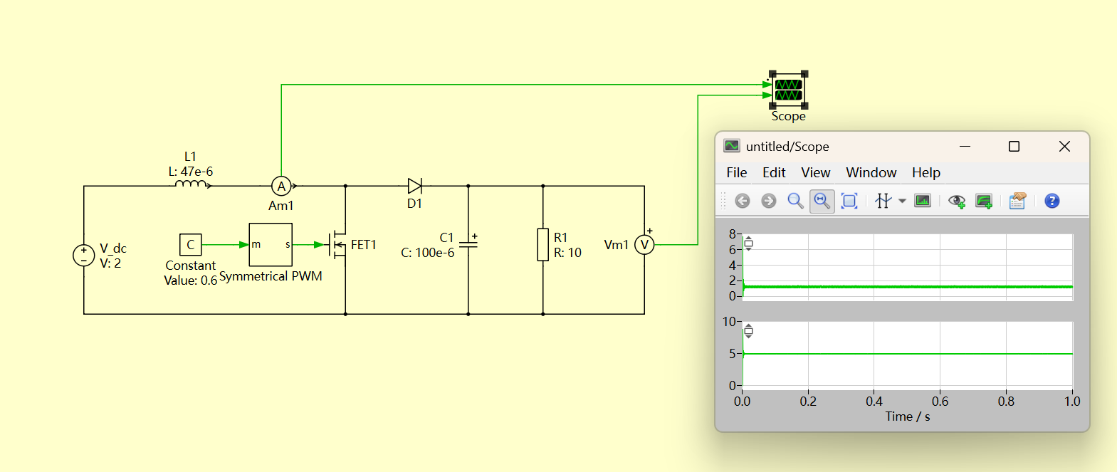
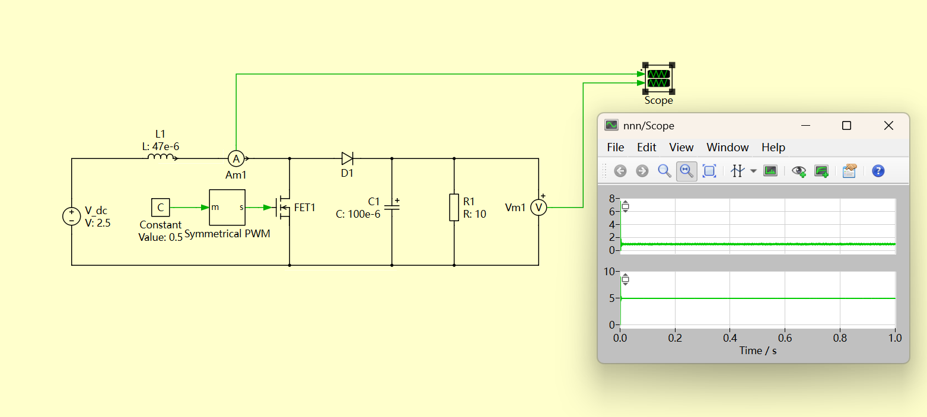
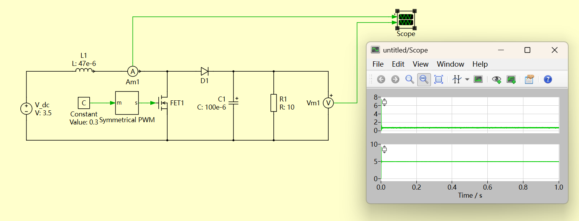

Initial Design Calculation
Ideal boost-converter duty-cycle range
1. Assumptions and governing equation
Assumptions. Ideal components, continuous-conduction mode (CCM), and steady-state operation.
For an ideal boost converter operating in continuous-conduction mode (CCM) and steady state, the duty cycle D can be derived using the inductor volt-second balance principle (literature).
The duty cycle is obtained using inductor volt-second balance: the average inductor voltage over one switching period is zero.
v_{L} = L · di_{L}/dt | (1)

V_{L,avg} = 0 | (2)

2. Inductor voltage during each switching interval
Interval | Duration | Inductor voltage | Volt-second contribution
MOSFET ON | DTₛ | Vᵢₙ | Vᵢₙ · DTₛ
MOSFET OFF | (1 − D)Tₛ | Vᵢₙ − Vₒᵤₜ | (Vᵢₙ − Vₒᵤₜ)(1 − D)Tₛ

3. Apply volt-second balance
V_{in}DT_{s} + (V_{in} − V_{out})(1 − D)T_{s} = 0 | (3)

V_{out} = V_{in}/(1 − D) | (4)

D = 1 − V_{in}/V_{out} | (5)

4. Numerical duty-cycle range
For V_{in} = 2.5–3.5 V, V_{out} = 5 V:
Input condition | Calculation | Duty cycle
Vᵢₙ = 2.5 V | 1 − 2.5/5 | 50%
Vᵢₙ = 3.5 V | 1 − 3.5/5 | 30%
Required ideal duty-cycle range: 30% ≤ D ≤ 50%
5. Output-current range
From the specified output-power range, Pₒ = 0.5–5 W, at Vₒ = 5 V:
Iₒ = Pₒ/Vₒ ⟹ Iₒ,min = 0.5/5 = 0.10 A; Iₒ,max = 5/5 = 1.00 A | (6)

6. Inductor selection for CCM
The preliminary value is selected so the ideal converter remains in continuous-conduction mode at the minimum specified load. During the MOSFET ON interval:
ΔIₗ = VᵢₙDTₛ/L = VᵢₙD/(Lfₛ) | (7)

At the CCM/DCM boundary, the minimum inductor current is zero, so ΔIₗ = 2Iₗ,avg. For an ideal boost converter, Iₗ,avg = Pₒ/Vᵢₙ. Therefore:
Lcrit = VᵢₙD/(2fₛIₗ,avg) = Vᵢₙ²(1 − Vᵢₙ/Vₒ)/(2fₛPₒ) | (8)

Worst-case check over the full input range. Use Pₒ,min = 0.5 W, Vₒ = 5 V and fₛ = 100 kHz. Maximising Lcrit(Vᵢₙ) gives Vᵢₙ = 2Vₒ/3 = 3.33 V, which lies inside 2.5–3.5 V:
Lcrit,max = (3.33 V)²(1 − 3.33/5)/(2 × 100 kHz × 0.5 W) = 37.0 μH | (9)

Design input | Value used
Minimum theoretical value for CCM | L > 37.0 μH
Selected standard value | L = 47 μH
Inductor current at 0.5 W, 3.33 V | Iₗ,avg = 0.150 A; ΔIₗ = 0.236 A
Minimum inductor current | Iₗ,min = 0.150 − 0.236/2 = 0.032 A > 0
7. Preliminary current-rating check
At maximum power and minimum input voltage, the ideal peak current is:
Iₗ,peak = Pₒ,max/Vᵢₙ,min + ΔIₗ/2 = 5/2.5 + 0.266/2 = 2.13 A | (10)

Component recommendation. Use a 47 μH inductor with low DCR, RMS-current rating ≥ 2.5 A, and saturation-current rating ≥ 3 A. These margins allow for converter losses and component tolerances; the final ratings must be verified using the simulated and measured peak current.

